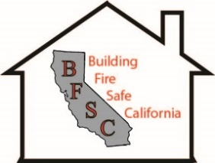
Building Fire Safe California an event at the North Coast Builders Exchange
January 18th 2018 From 10:00 to Noon
Subject: Designing and building structures to survive the next wild fire.
Topics:
- Starting design with fire in mind.
- Compare different building envelope options. Wood, Steel, Masonry, Insulated Concrete Forms and Sips.
- What are the best building methods for each wall assembly.
- A fire fighter’s perspective. What they wish you knew to help them save you and your home.
Building Fire Safe California
Our goal is to educate the building industry to embrace using methods and materials to build safer structures.
We want to facilitate the discussion of ideas for more resilient structures.
Kent’s Bio
Kent started in the trades as a carpenter. His diverse background in all phases of the building industry allows him to communicate to a variety of audiences within the building industry. His expertise is in high performance wall and roof assemblies. His presentations include wisdom, knowledge and experiences from his forty plus years in the building industry.
He is on a mission to make buildings fire safe!
How did these homes survive?
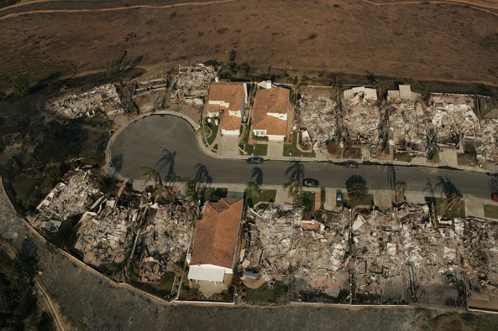
Please RSVP by January 16th to:
Building Fire Safe California This Event is being sponsored by Logix ICF
Kent Yonker and is free to attend.
(916)806-4207 kentbuildingfiresafecalifornia@gmail.com But please RSVP so I have enough coffee.

